* TIME COMPLEXITY & BIG O NOTATION

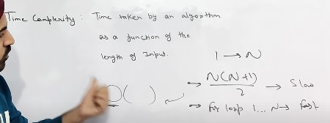

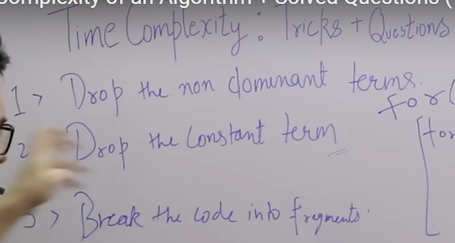

Below is the case for recursive calls.

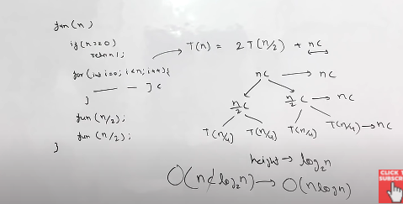

So here we are having 2 recursive cals in our function -> fun(n)

So for calculating time complexity we are keeping non recursive call that is iteration loop having n operations with ‘c’ as constant operations as ‘nc’ and recursive calls as 2T(n/2) ,

So for finding complexity we will go through tree approach where at the top we will have ‘nc’ operation that is from iteration loop and as we are moving forward we will divide it into branches as per recursive calls as here it is 2T(n/2) so it will break as T(n/2) and T(n/2) & so on replace the same with ‘n’ iterations as we go down i.e -> n,n/2,n/4,n/8…. Here so it makes it of log n complexity.

* One more example for recursion

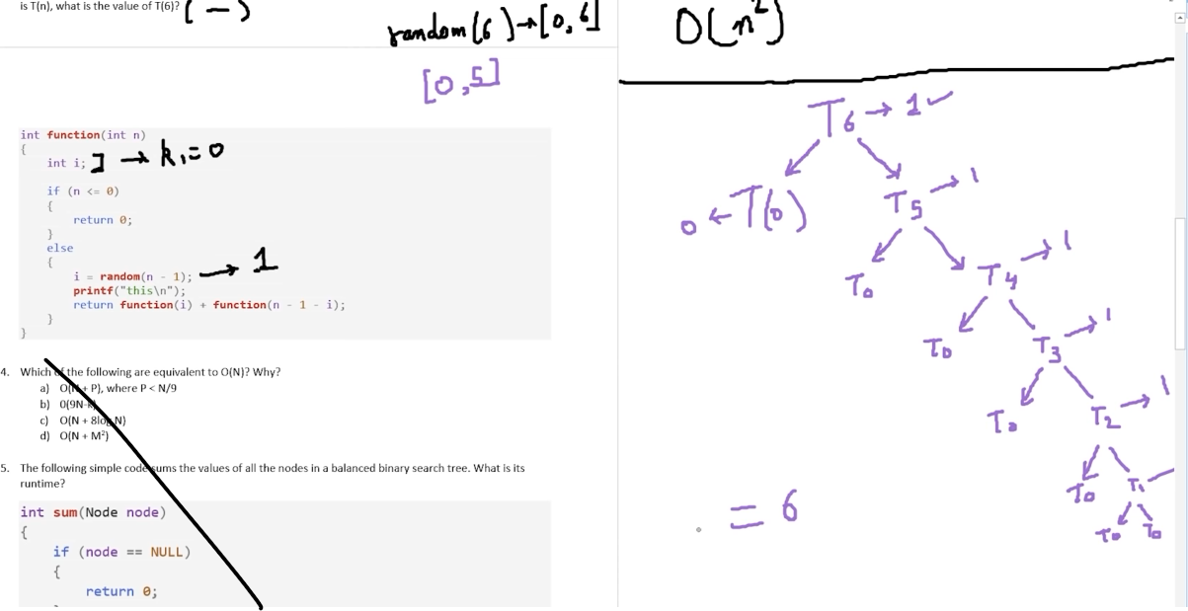

Here we are asked to calculate for T(6) so, for simplicity taking i=0 as it can be any random number, therefore answer is 6 units of time it will take to execute for T(6).

* 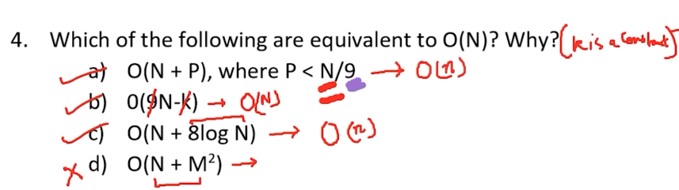

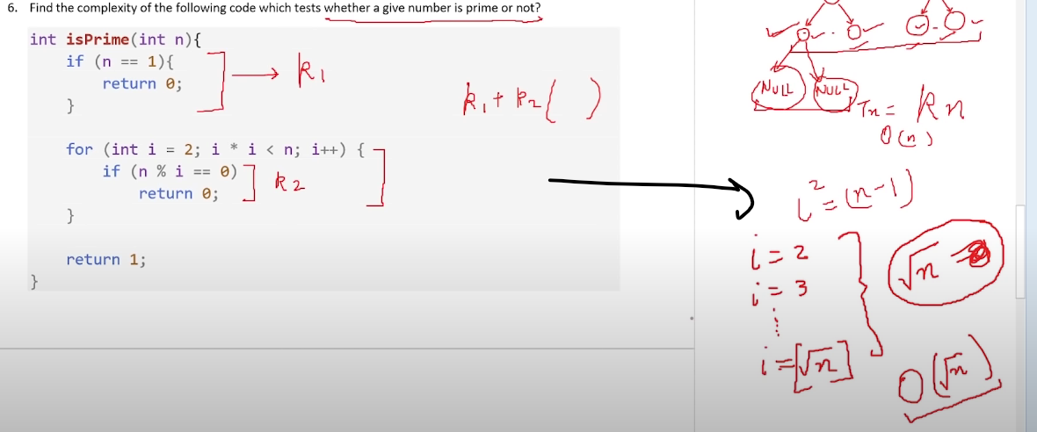

O( sqrt(n) ) - will be the complexity for above ques.

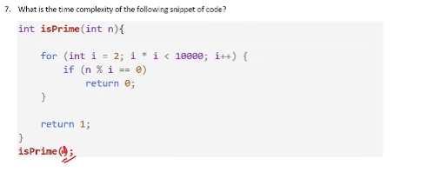

O(1) will be complexity for above question

* 10^8 operations per seconds are performed by online compiler.
* BIT MANIPULATIONs

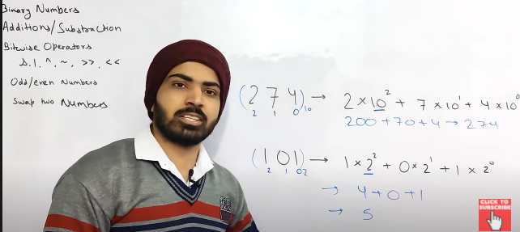

Above

1. [274] Showing normal number as base 10 that is the decimal value is always base 10.
2. [101] converting binary to base 10.

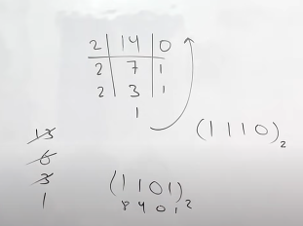

Here we are converting decimal to binary

Now we can convert it by:

1. By dividing by 2 and taking reminder in reverse order.
2. And now the easy way we will just see weather number is odd or even if odd add 1 else if even add 0 in reverse order , and now divide the number by 2 and take the integer value and do the same.

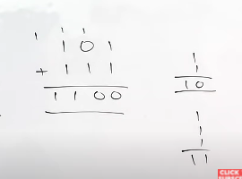

Above binary addition.

1+1 = 2 in binary its 1 0

1+1+1 = 3 in binary its 1 1

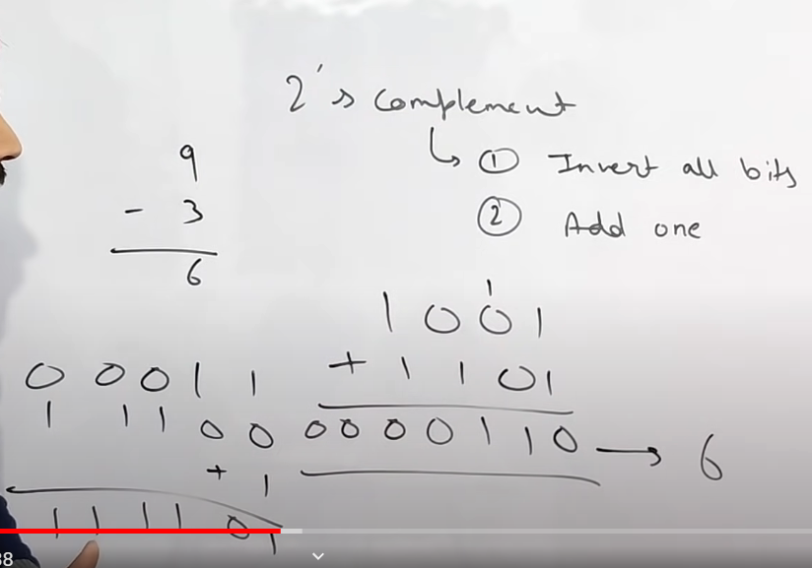

Similarly for subtraction if we have to do 9-3 then we will do it as 9 + (-3)

i.e ivert 3 by 2s compliment and then add it to 9.

9 – 1001

3 – 0011

2’s compliment of 3 i.e inversion of -3 will be 110 .

Finalyy its 1001+1110 here for 2’s compliment of 3 ,1 is added in front coz it depends on the number of bits i.e 32 or 64 so there are not only 3 bits in total in begin also It contains bits as 0 which becomes 1 after 2’s compliment.

* Bitwise Operators :

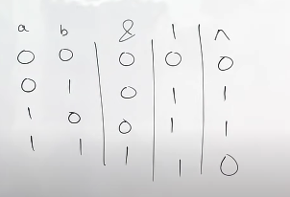

& -> And –> both 1 then 1

| -> Or -> any one of them is 1 then 1

^ -> XOR -> if borh are different then 1

~ -> inverse bits -> 0 ka 1 aur 1 ka 0

>> -> bit shifting towards right ‘n’ times

<< -> bit shifting towards left ‘n’ times.

Below is example for n=2;

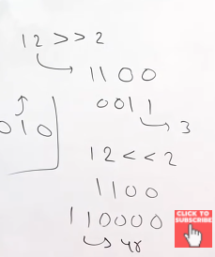

Example here we are shifting bits 2 times right and left.similarly can be done for any value .

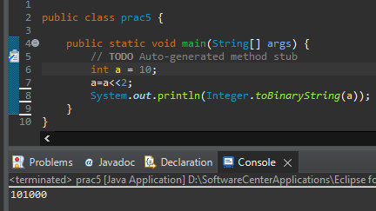

* Right shifting by 1 means – divide by 2.
* Left shifting by 1 means – multiply by 2.

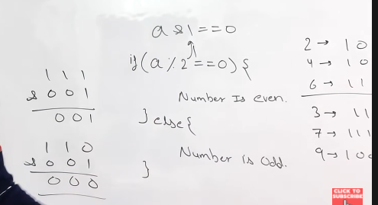

If & of number with 1 is 1 then that number is odd number.

Else the number is even.

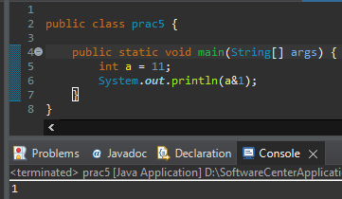

* Swap 2 number without using 3 variable/ using bitwise operator.

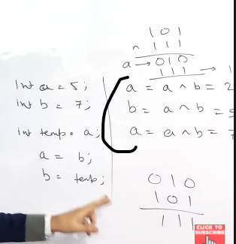

Steps: do xor 3 times.

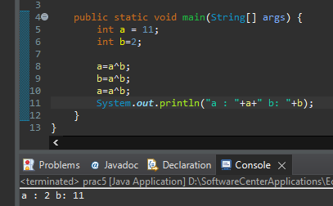

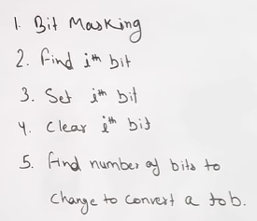

1. Bit Masking
2. Get i-th bit.

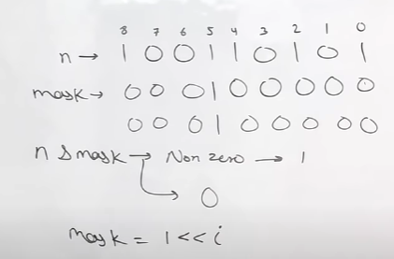

So here we have to find the i-th bit in ‘n’ so here we took help of ’&’ operator with 1 and masking .

Since here we have to find 5th bit from left So by masking we shifted 1 to the left by 5 and then using masking we made all other bits as zero.

Now if ‘&’ of that bit return 1 then its 1

Else 0.

1. Set i-th bit:

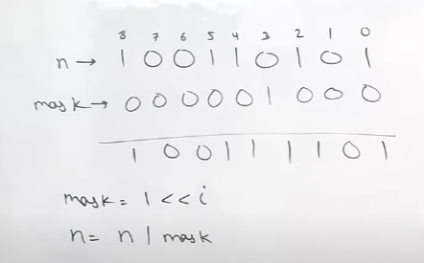

Similarly as above but here we will do ‘OR’ with the masking.

1. Clear i-th bit

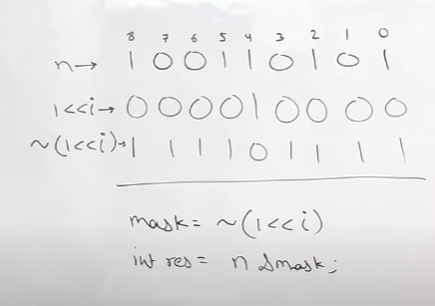

Here shifted 1 to left for the place we have to clear .

Then ‘NOT’ operator is used

Then ‘&’ operator will be used and so the result .

1. Number of bits to change to convert ‘a’ to ‘b’:

Simply we will just do XOR operation and count the number of 1’s in the XOR result.

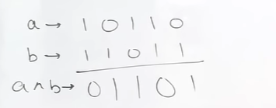

* Number of bits in binary of a number is : log2n +1.
* Number of digits in a number is : log10n +1.

Where n is the number in decimal [also we’ll take integer value of log i.e the floor value].

Ex for n=13.

log2n +1 => 4 = 1101

log10n +1 =>2 = 13

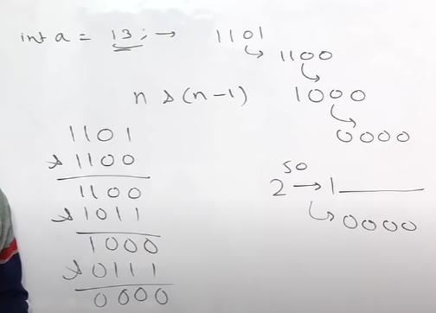

Similarly we can count 1’s by ‘&’ operator i.e ‘n’ & ‘n-1’

Number of operation will be = count of 1.

Terminating condition will be all bits 0.

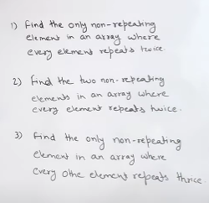

* Properties of XOR

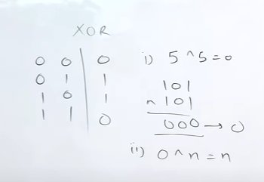

* Using above properties we can solve ques 1 i.e find one non repeating element.

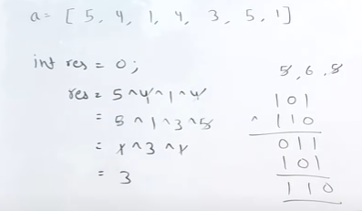

* Mathematics and number theory algorithms:

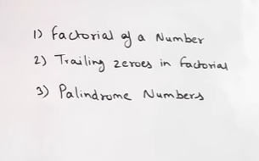

* So for factorial we know its very easy n*(n-1)!
* Trailing zeroes in factorial :

So factorial of a number can be very large that we can store inside int or long , even if we store it counting the trailing zeroes will be not a easy task wrt to time complexity so why not we create a universal formula for getting trailing zeroes in number for factorial.

So we know clearly that we get zero in the last by multiplying number by 10 i.e combination of 2*5 and also we know in factorial we get less number of 5 than 2 so we can simply divide the number with 5 which will give us the total number of zeroes in last of factorial of that number.

Algorithm Abdul Bari

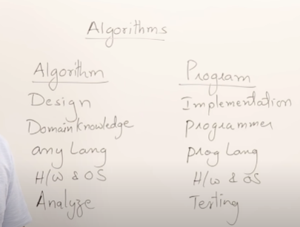

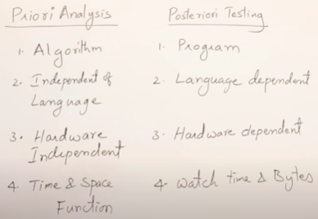

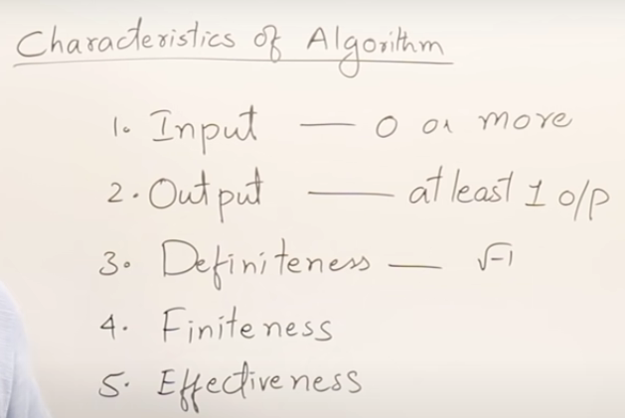

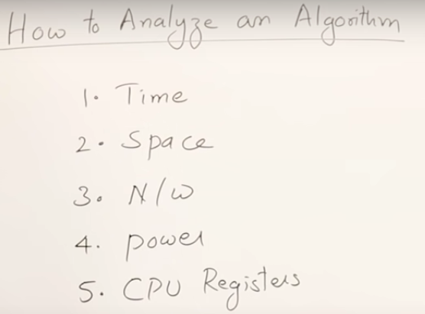

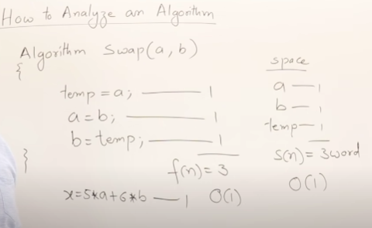

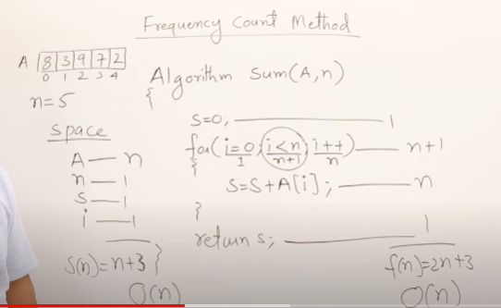

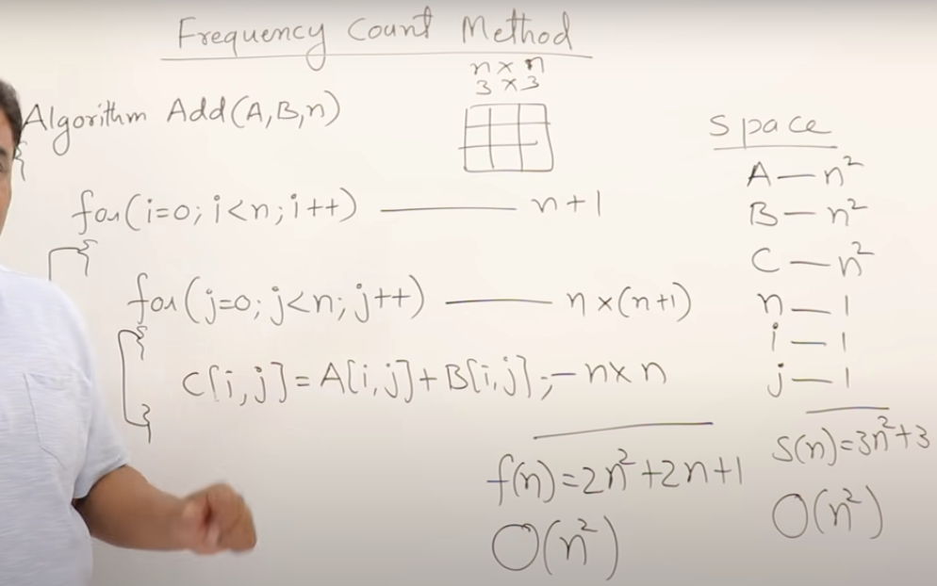

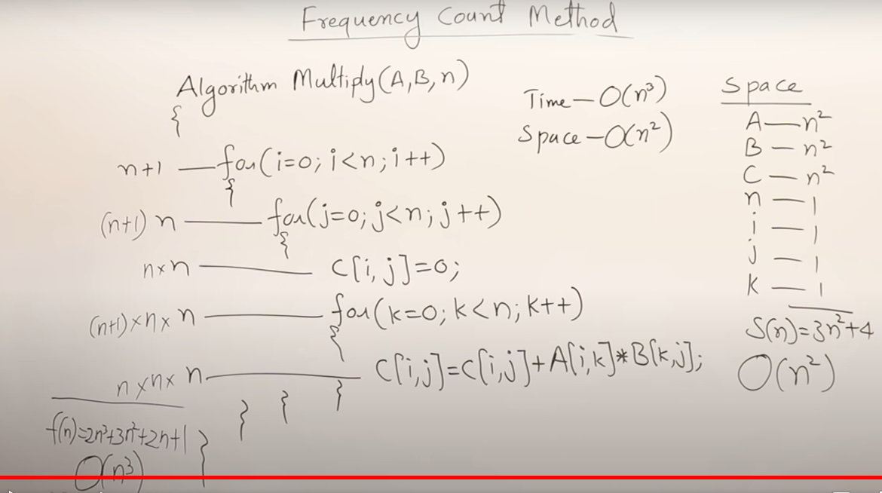

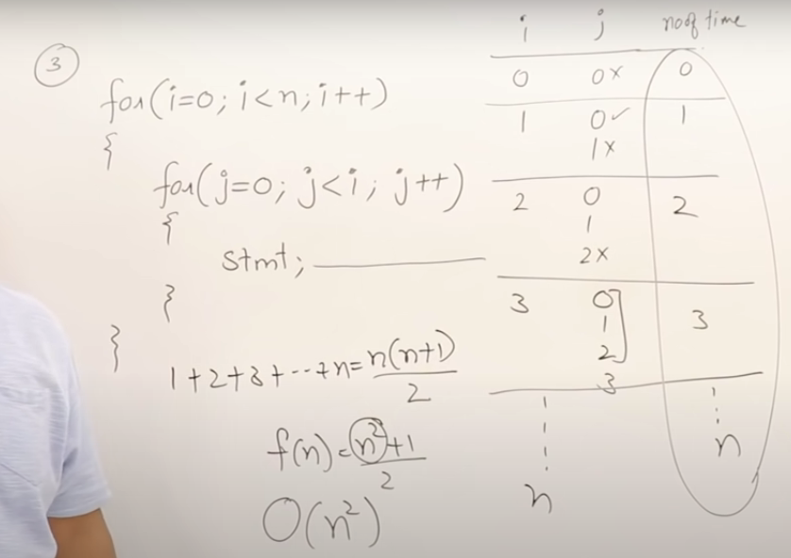

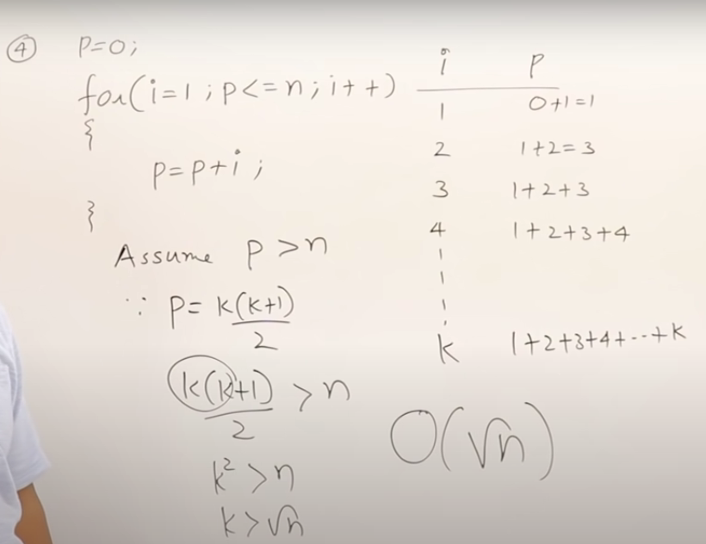

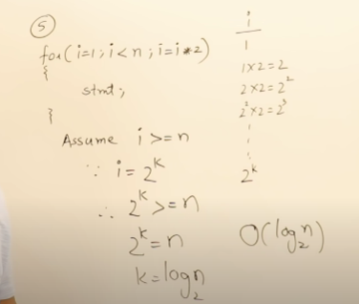

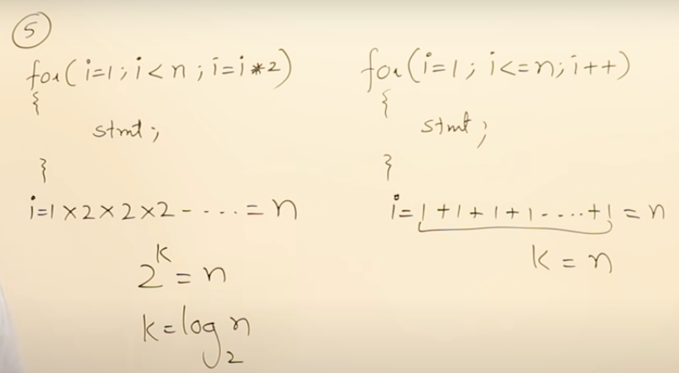

Other way to calculate time complexity

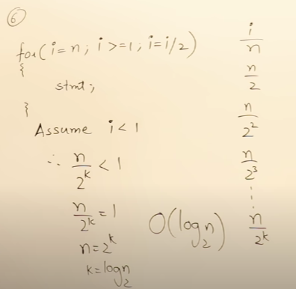

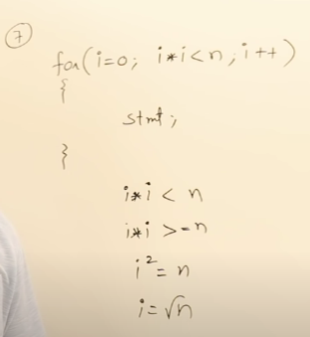

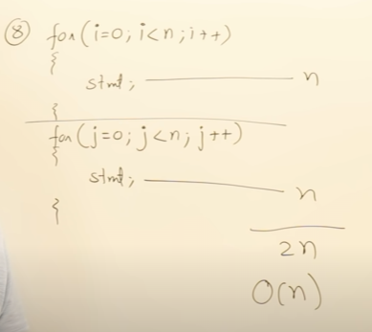

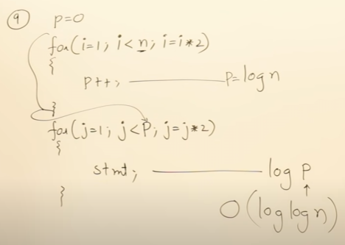

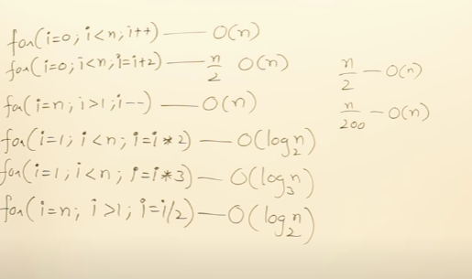

Try to remember above still if u cant just go step by step.

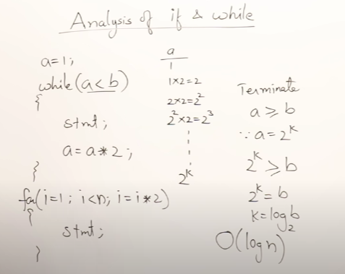

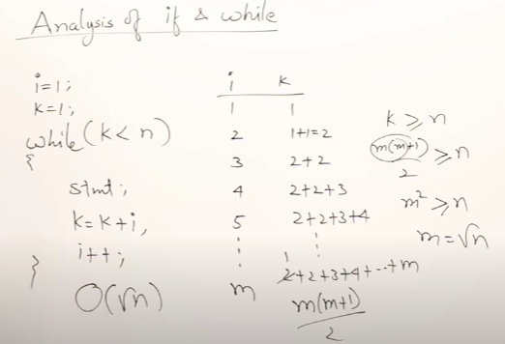

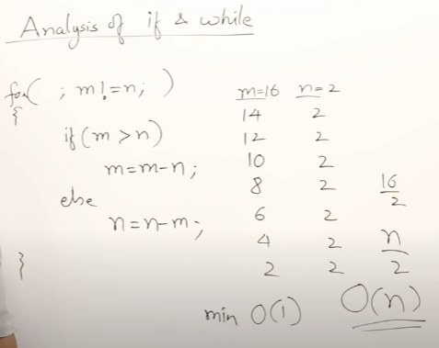

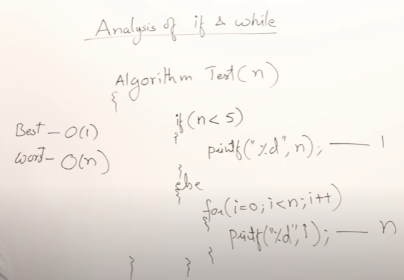

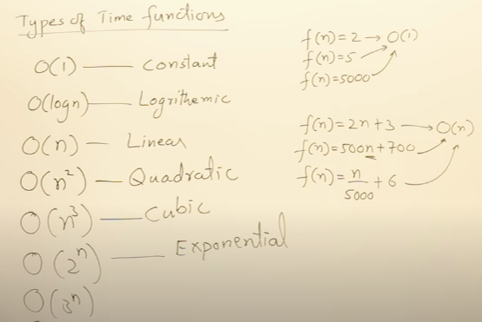

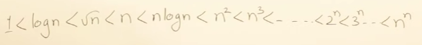

Order of Big O notation Time function.

* Asymptotic notations.

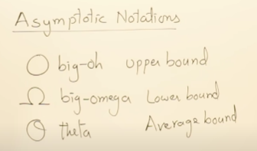

Don’t misunderstand this upper / lower bound with best case or worst case, this are just complexity bounds.

Further images u will see in more detail.

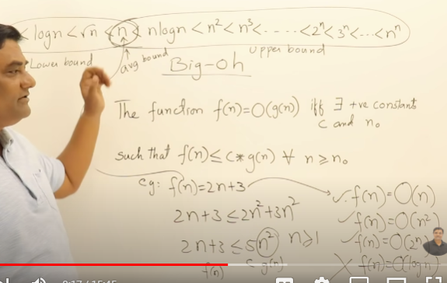

So the upper bound i. e Big O is any value above or equal to average bount i.e Theta notation.

Still we take the closest one as in above example O(n) is closest to the bound. i.e 2n+3<= 2n+3n.

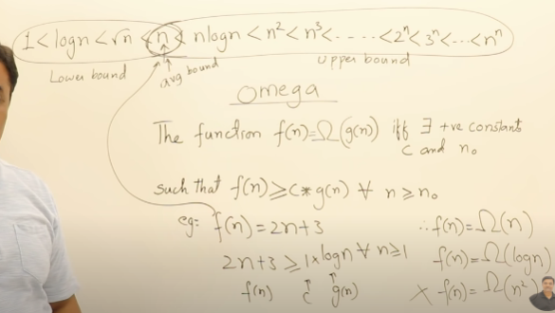

Similarly for lower bound i.e Omega notation any value below or equal to average notation.

But we always provide nearest value to theta although the lower value is also correct but not useful.

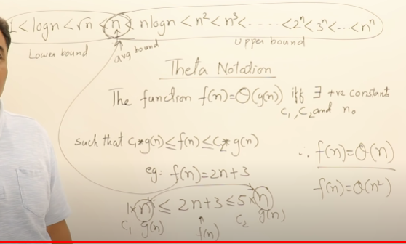

Same we can get for average notation i.e theta notation. i.e the exact average value .

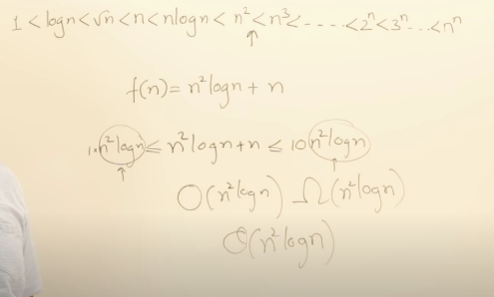

Above image all three that is big O , Omega and theta all are having same complexity since satisfying the condition for the same .

So, Don’t misunderstand this upper / lower bound with best case or worst case, this are just complexity bounds.

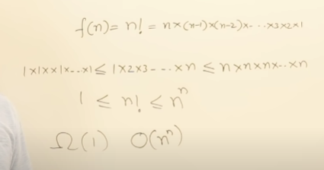

In above example of factorial of number we can not find the average bound that is the theta for factorial we can get lower bound that is 1 and upper bound that is nn.

Which means for lower value it will go close to 1 and for higher values it can go upto nn.

So we can not find exact place in order table for factorial of n.

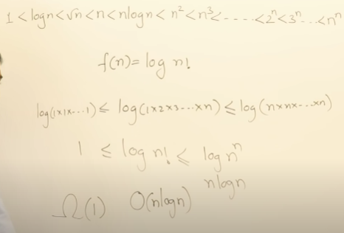

Similarly for log (n!) we can find Big O & Omega but not the theta so here are the places where we need to find upper and lower bounds.

* Properties of Asymptomatic notation :

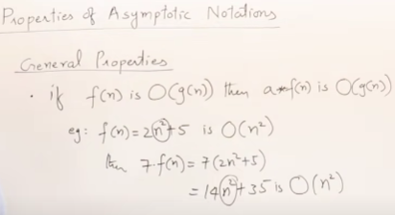

Same for omega and theta.

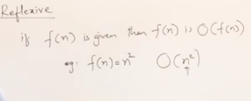

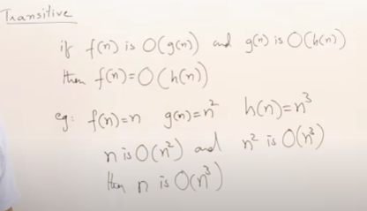

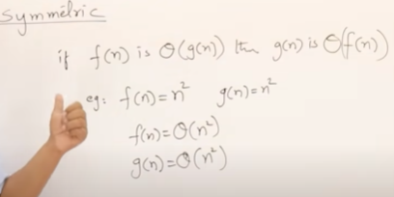

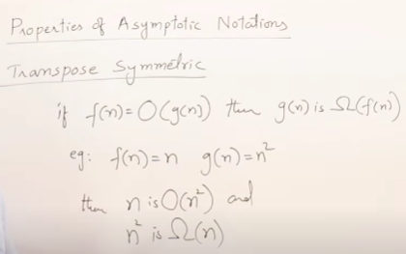

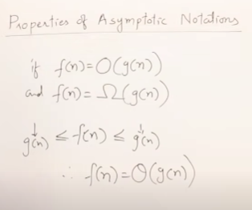

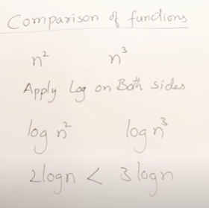

We can also do it by taking some sample values but for complex functions we can take log both the sides.

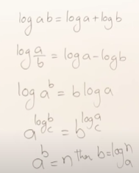Some log formulas.

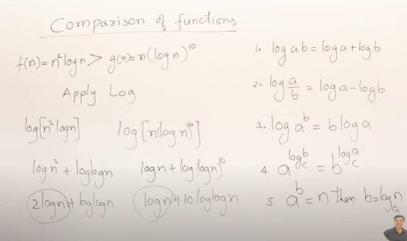

Example to compare 2 complex functions.

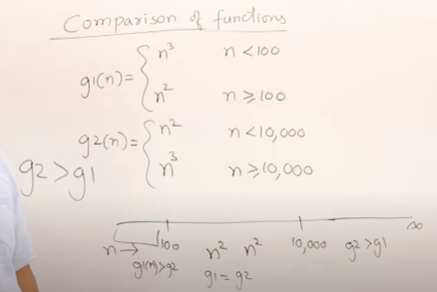

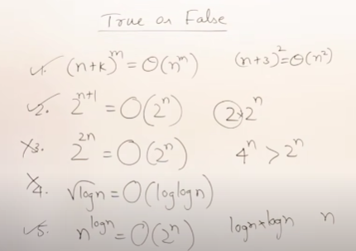

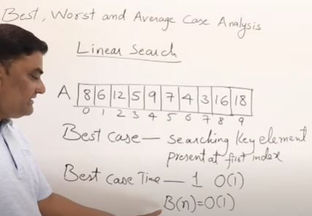

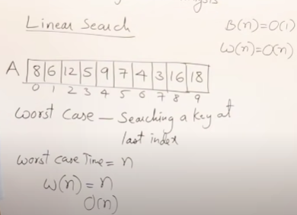

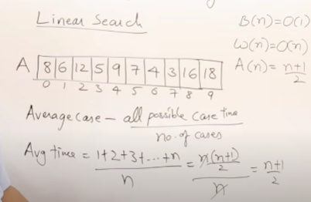

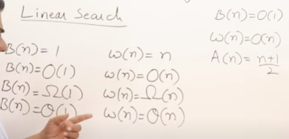

Here we see for best and worst case both O,omega and theta all are same.

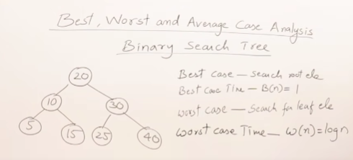

Lower valued elements are at lest and higher valued elements are at right.

Above is balanced binary search tree.

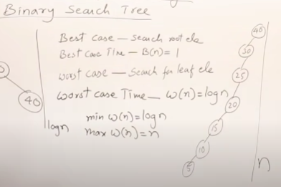

Above is the case where worst case can be n.

Since it is also binary search tree so all the lower value element are on left.

So min of worst case can be log n and max can be n.

* Disjoint sets : means no elements are common in these sets.

Famous algorithm that uses Disjoint sets is kruskal’s algorithm which detects the cycle in a graph.

<https://www.youtube.com/watch?v=wU6udHRIkcc&list=PLDN4rrl48XKpZkf03iYFl-O29szjTrs_O&index=17>

leaving for now was being confused and sleepy so.

* Divide and Conquer

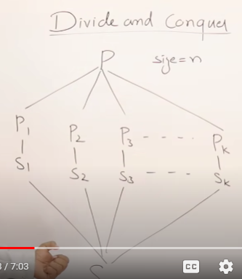

Here in algorithm divide and conquer doesn’t means dividing main task into subtask of different functionality instead its same as the main functionality . Ex : if the main task is to sort a array so we divide it in smaller chunks and recursively call the main task which will sort smaller chunks and then the final result will be combination of all sorted chunks collected together.

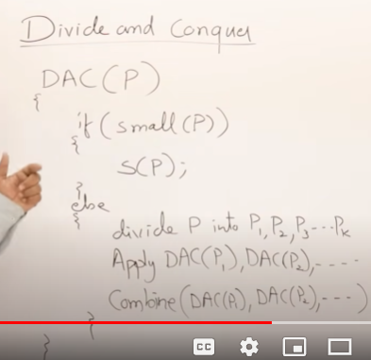

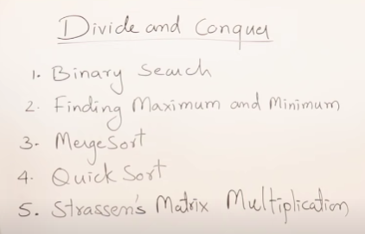

Above are divide and conquer algorithms.

* For recursion time complexity

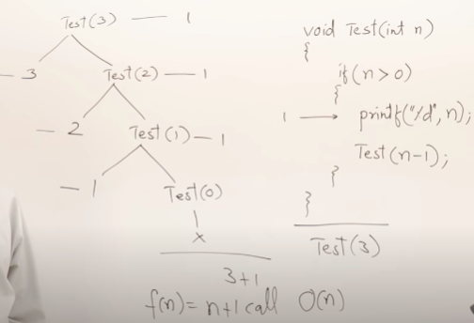

So the recurrence relation for above will be.

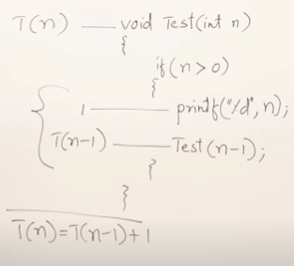

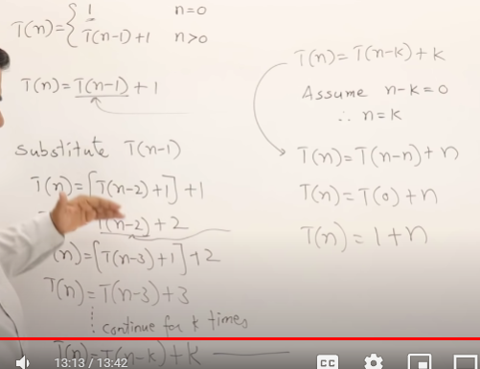

Here also we got same time that is 1+n by back substitution and tracing.

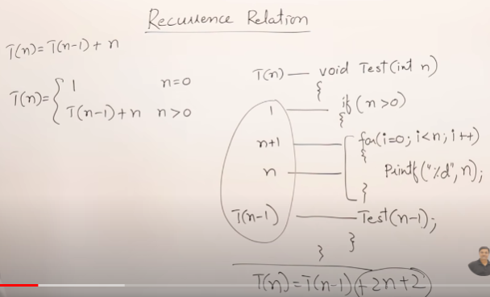

Example 2 : is having time as T(n-1) + n.

Where T(n-1) for recursive calls and n for “for loop ”

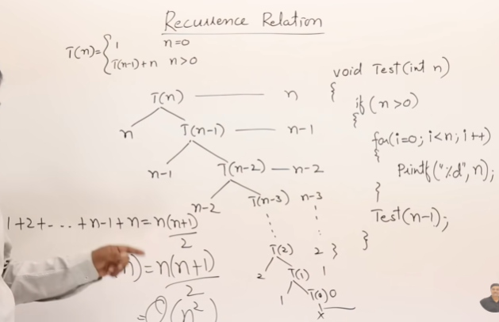

So we can solve above function using recurrence tree by breaking down function for each calls which we can see as sum of n natural numbers.

So the time complexity becomes : O(n2)

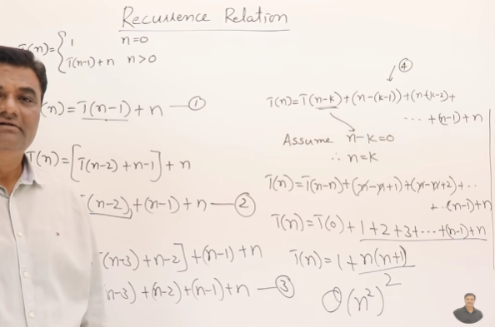

Here also we got same time that is 1+n(n+1)/2 by back substitution and tracing.

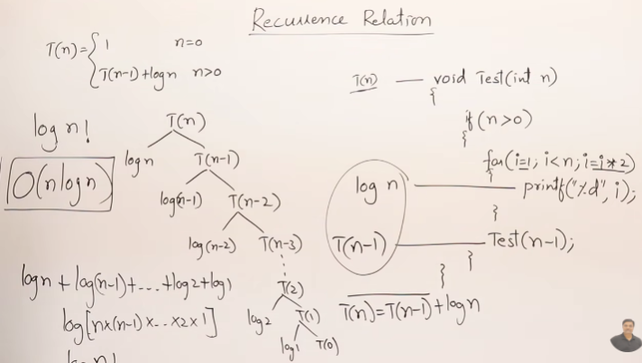

As we know the internal for loop has complexity of log n so for each recursive call it will be logarithmic value of current ‘n’ value which will be n , n-1,n-2 ….. to 1 . Using recurrence tree.

So its time complexity is log(n!) so the upper bound for it is Log (nn) = n Log n.

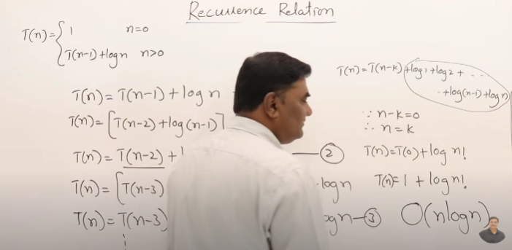

Same using substitution method.

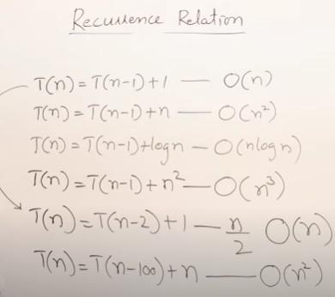

So the CRUX for recurrence relation is shown above that is multiply value after plus with ‘n’.

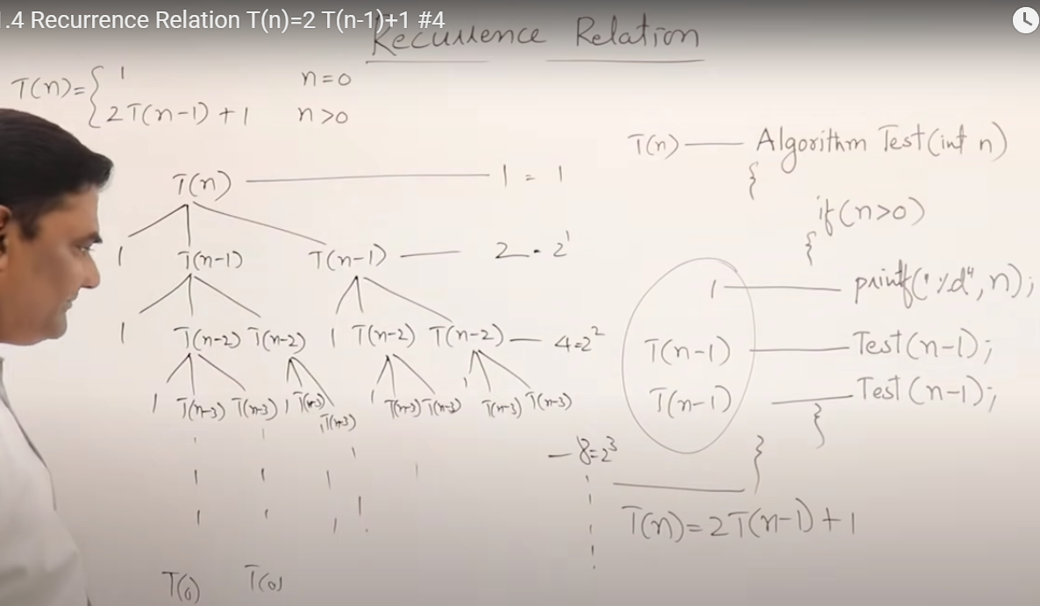

So by recurrence tree the total complexity is the Geometric progression of 2 , 22, 23, 24, 25….. 2k .

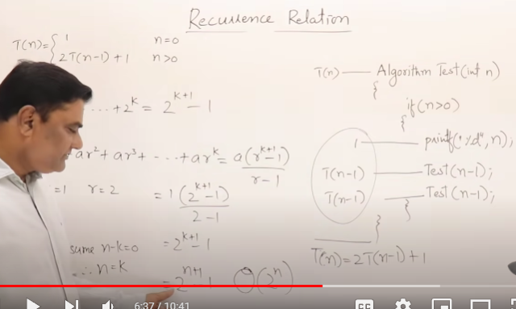

So by sum of GP formula above is the complexity i.e 2n.

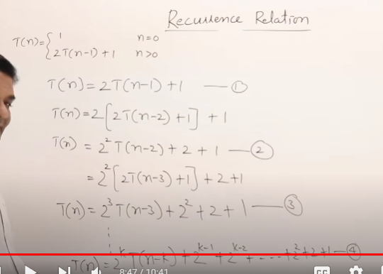

Same above function solving using substitution method.

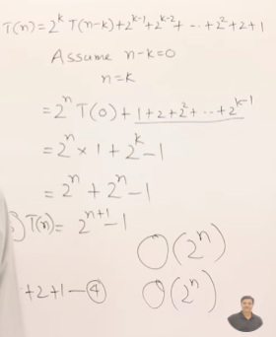 So the complexity is same i.e 2n.

* CRUX for finding complexity for decreasing functions.

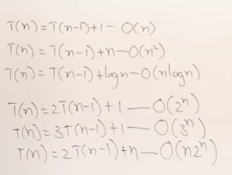

For this we have masters theorem which we will see in below image which is written in more generalized form.

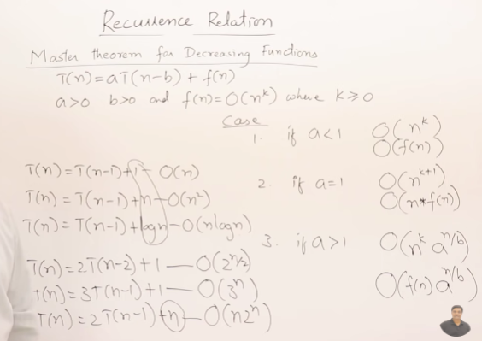

So this is a kind of formula for calculating time complexity for cases which seems to me tough right but still have a look at it if required further.

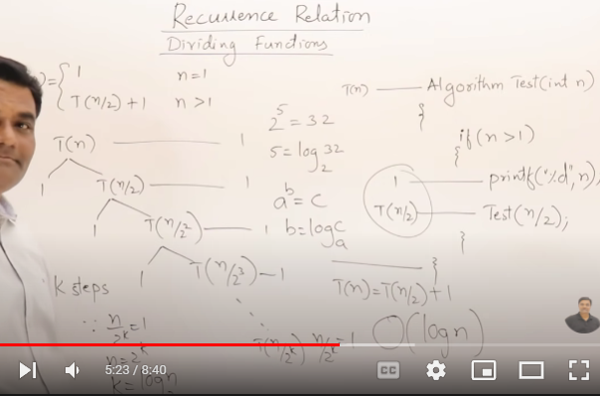

By recurrence tree method.

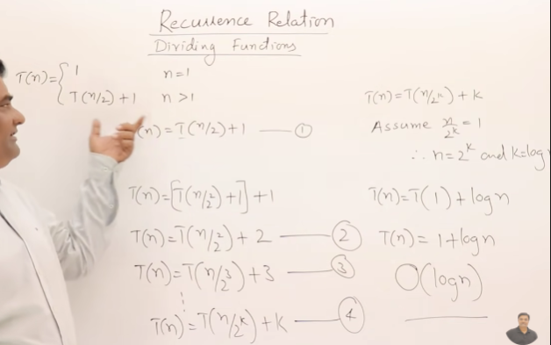

Same using substitution method/induction method.

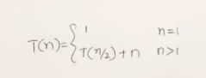

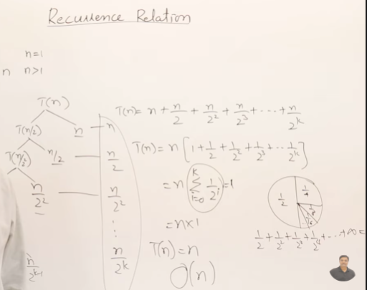

For T(n/2)+n using recurrence tree.

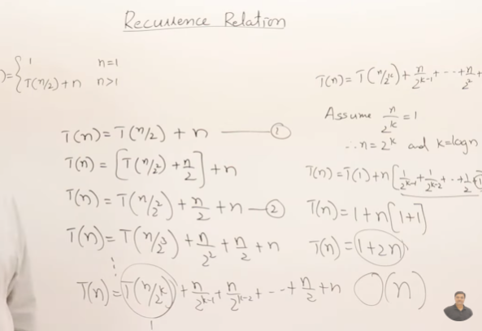

Same using substitution method.

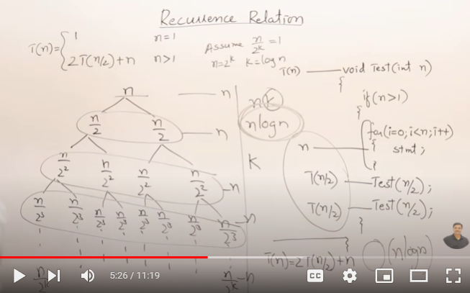

Other example.

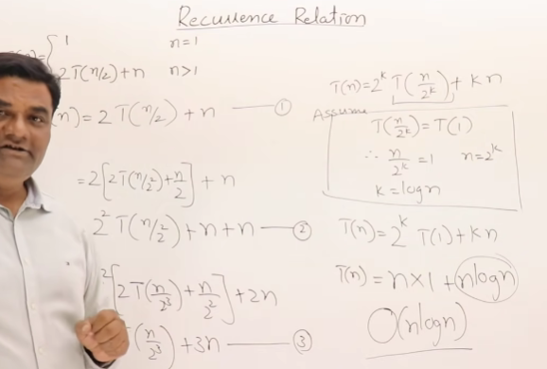

Same using substitution method.

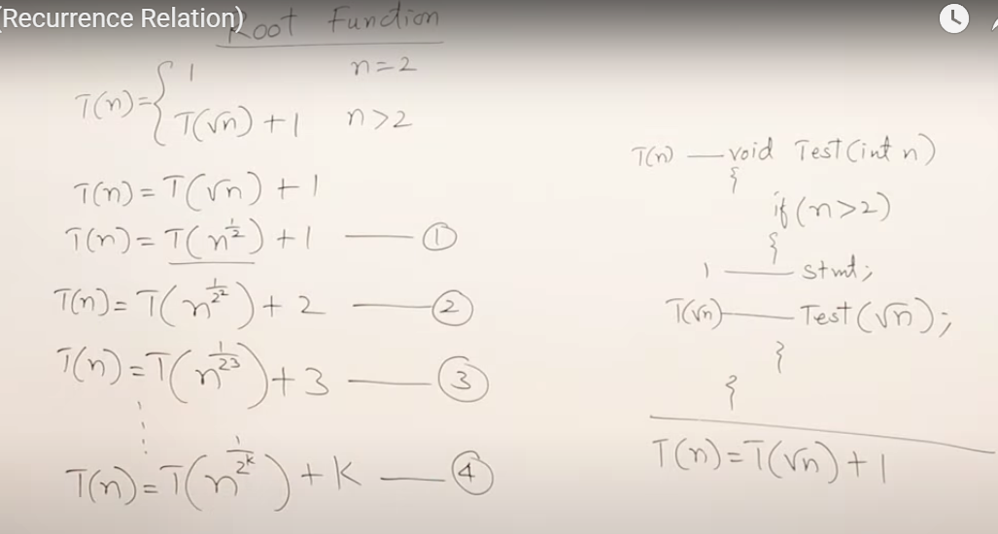

Above is example for Recurrence relation for root n recursive function.

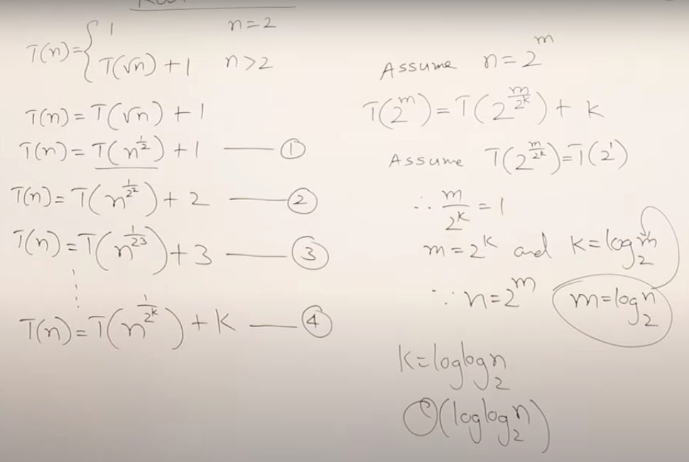

Since in above code smallest value is 2 so we assume that n is in powers of 2 i.e 2m.

* Binary Search:

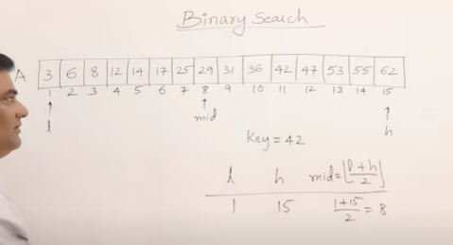

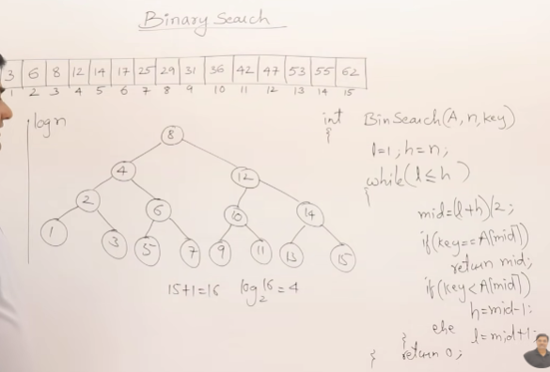

Above is the iterative approach for binary search.

Best time complexity O(1)

Worst Time complexity O(Log n)

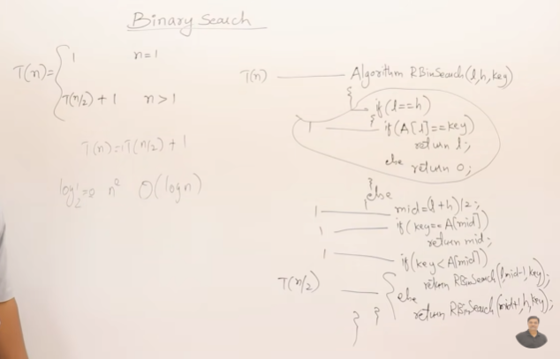

Above is the recursive approach to solve binary search.

Having time complexity of Log n.

* Heap Sort :

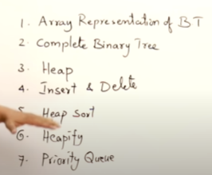

Above topics to be covered before directly jumping to heap sort.

1. Array representation of binary tree.

Here for sake of theory and understanding we are taking index from 1 so that theoretically we can find out the actual place for each node in binary tree.

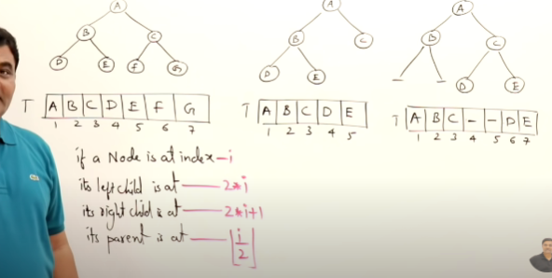

Above we can find left/right child and parent for any ith index using above formulas written in red.

Now as we can see the 3rd tree there is missing child for B so in Array also we will need to leave blank spaces for that in similarly level by level order.

1. Complete binary tree : a binary tree with max 2k number of nodes at that height is called complete binary tree and in its array representation there should be no gap for any node in between the array.

Full binary tree : if there is exact 2k number of nodes at that height is called full binary tree.

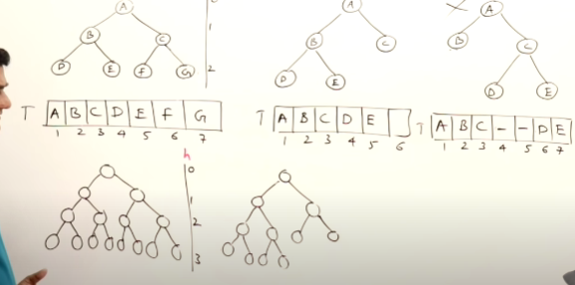

In above image :

1 tree is complete as well as full binary tree.

2 tree is complete binary tree.

3 is not complete binary tree.

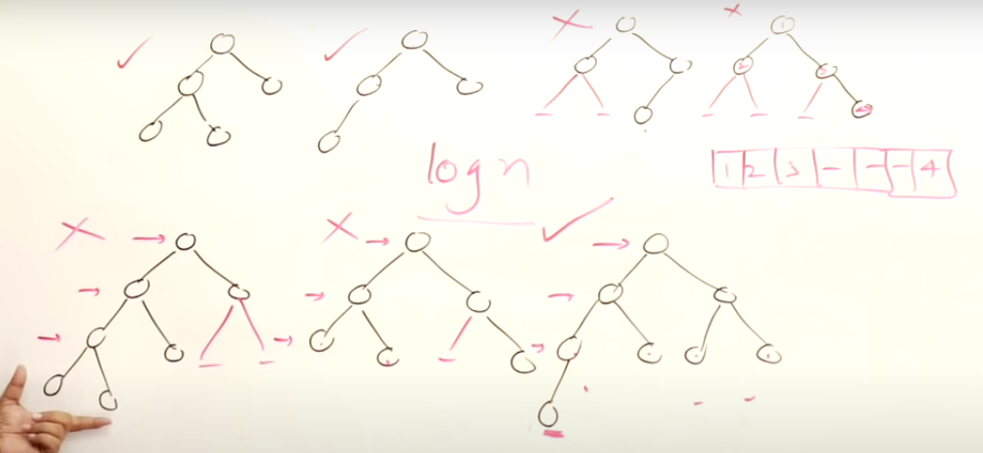

Above tick -> complete binary tree

Cross -> not complete binary tree.

1. Heap : is a complete binary tree.

* Min heap : All parent node will have value less then there children.
* Max heap : All parent node will have value more then there children.

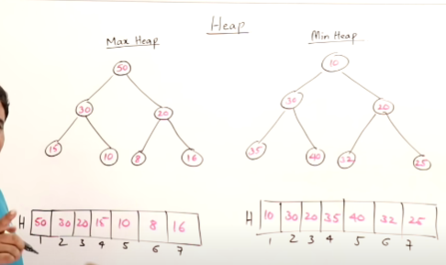

* Now we’ll se how to perform insert and delete operation in heap [here for max heap similarly done for min heap].

1. For insertion :

We move from leaf towards root by swapping from parent

i.e if inserted value is greater move to **insertedLocation/2** is the parent and then modify so on until insertedElement reaches to the place where it should be in tree.

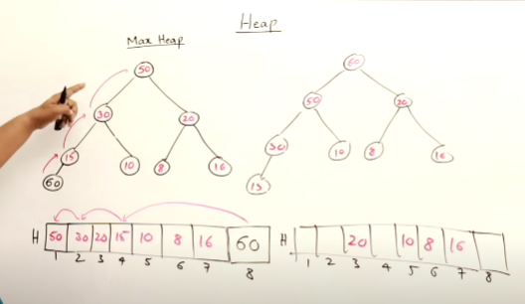

So the worst case time complexity depends on height of tree i.e O(Log n)

And the best case is constant i.e O(1)

1. For deletion : we always delete from the top of heap i.e the root element .

Steps : after deleting top/ root element we will place last element from the array to the root.

So now it is complete binary tree but not max heap.

So now to make tree as max heap now we will start shifting that node to its position as per the requirements of max heap so that it can come back to max heap.

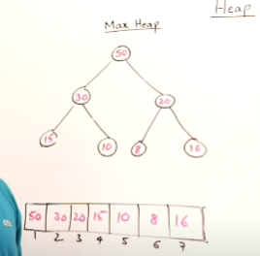

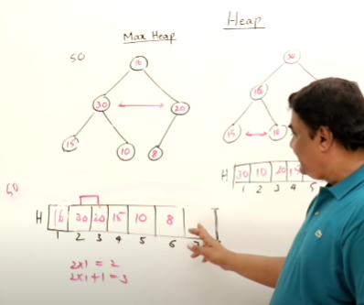

So now here the arranging 16 in the tree and so in array.

* Heap Sort : while we delete element from max heap the maximum value[root element] from heap is deleted and the last element from the list comes and replaces it and the we further do swapping to make it max heap angain.

So now if we put the deleted element from the last place that becomes empty by which we replaced the top value then as we further delete whole heap from top and repeat this step for all elements in max heap then the new list will be contain sorted element.

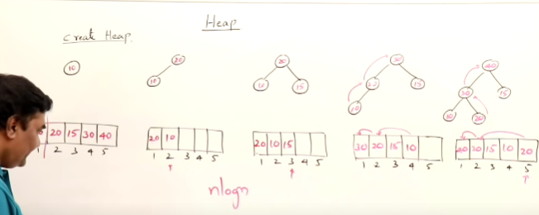

Total time taken to create heap is nLogn ; n-> for ‘n’ inputs and Logn for worst case to move all the inserted nodes to the root .

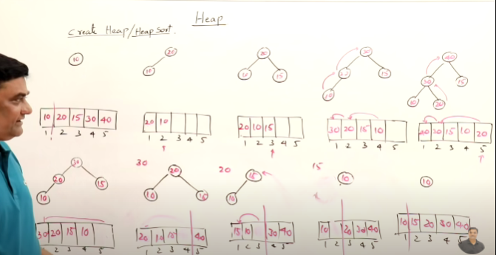

Below is the deletion of max heap for sorting list.

Same for deletion Big O is nLogn.

* Heapify : using heapify we create min/max heap from bottom to up that is it is in reverse order so here the time complexity is O(n) of how we used previously top to down approach the complexity was O(nLogn).

So here we just insert the values in normal fashion in Complete binary tree in the same order of what is given & then we start comparing from bottom n/2 values that is second last row and do the swapping accordingly to the lower nodes that is at each parent the swapping is 1 in worst case.

So below have derived the O(n) for the tree to create

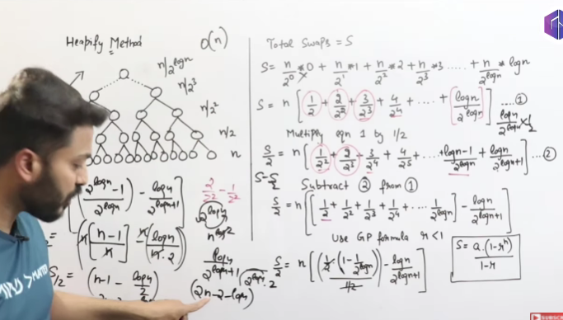

Here in S= ………………… equation its showing :

1. For leaf nodes i.e 0 :
2. As we go in reverse order i.e 2 from last the max swap is 1 and number of nodes at that level is n/2 ….. and so on the series is created.
3. So now as going forward we can see it’s A.G.P series numerator -> AP denominator -> GP so for calculating further multiplies whole series with ½ and now the series become GP with some extra values so after calculating below we can see.

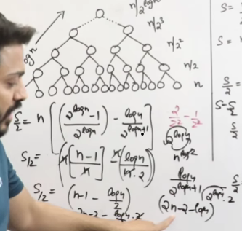Hence by deriving we get to know the time complexity for heapify is O(n).

* Priority queue : it is not like normal queue First In First Out.

Here the priority is number itself.

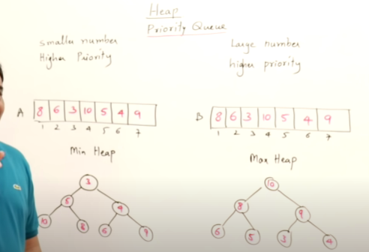

Best data structure for implementing Priority queue is Heap which takes Logn time for insertion and Logn time for deletion.

Where as if we use array it will take order of O(n) time for fetching /deleting element in it.

i.e if we have to delete element from array we will have to shift each element to left.

* Merge Sort :

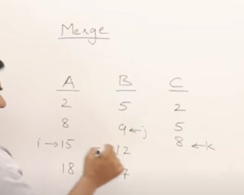

Here if we have to merge 2 sorted array , we will take 3 variables here :

i & j: for comparing which is smaller from A & B should be copied in C and k will be moved to next value.

And so on the Array A&B will get merged.

If any 1 of i or j gets equal to its size next whole sorted array which is not reached end is moved directly to end of new merged sorted array.

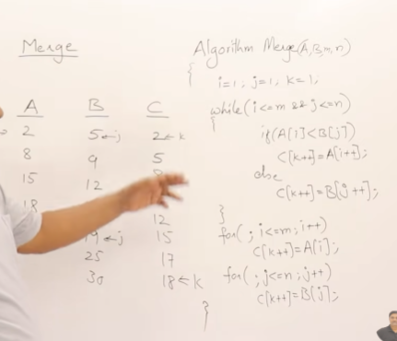

Above is the logic for implementing merge operation.

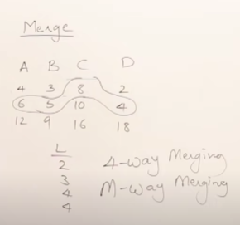

If we have more than 2 lists to merge so above is image if we are merging all 4 toghether.

But we can also do like 1 merge 2 list and then the sorted one with the third …… and so on

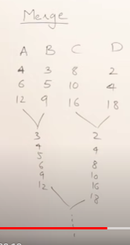i.e we can merge pair of 2 at a time.

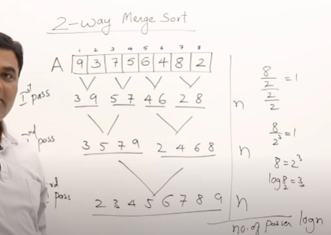

For sorting using 2 way merging is breaking whole list in 2 subarrays.

Total time complexity is ‘n’ for max number of merges in each level ang total levels is height of tree i.e Logn.

So O(n*Logn).

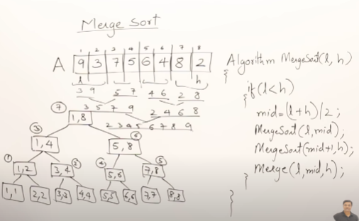

Here is the algorithm showing how the merge sort is being performed for each pair in recursive call.

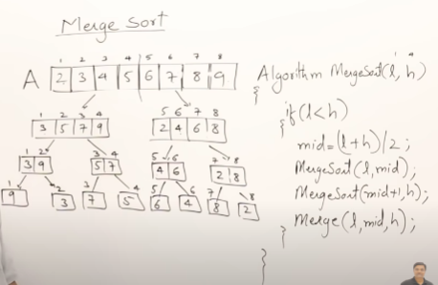

Example for above algo. This is what happen after sorting at each level.

* Quick Sort :

Here also we will implement divide and conquer strategy ,by taking 1 pivot element here in below image taking first element as pivot now all the value less than pivot is to the left of pivot and all the value greater than pivot is to the right of pivot.

As shown below:

Done by swapping ith value if greater than pivot with the jth value if its less than pivot, process terminates if i > j then swap the pivot with j.

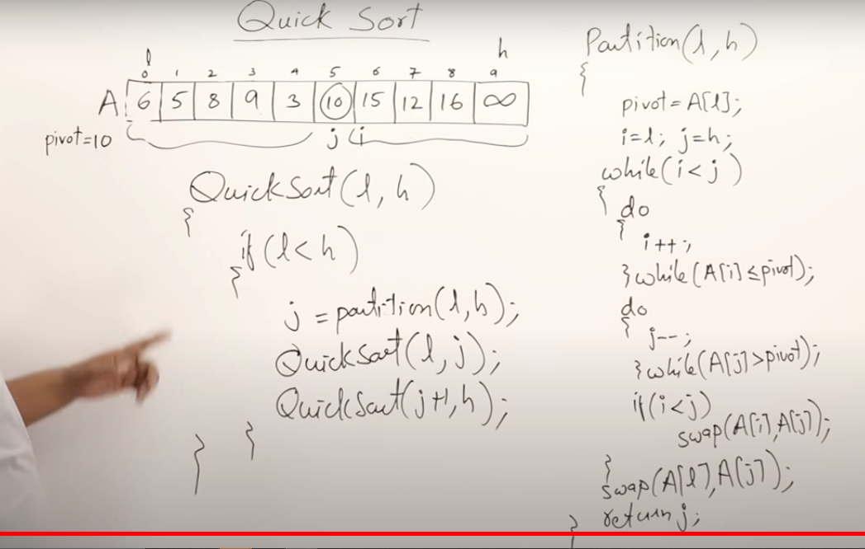

Partition method returns partition position for pivot.

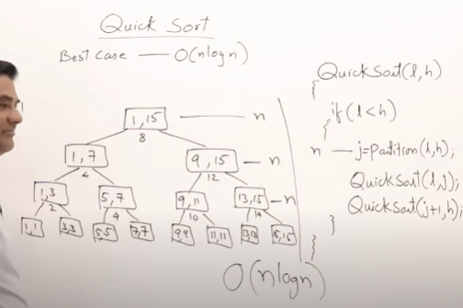

This will be best case if always pivot element is lying in the middle of list.

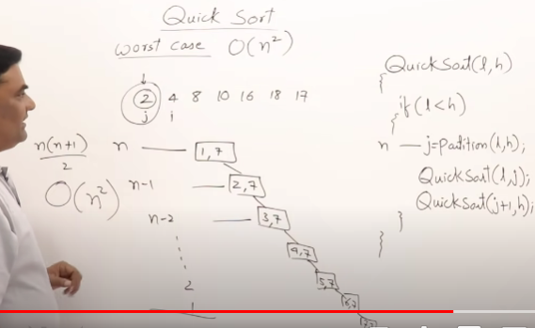

Worst case for merge sort is when list is already sorted i.e O(n2)

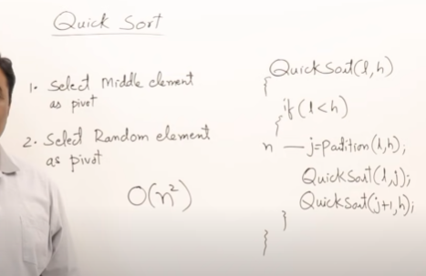

We can reduce worst case by taking middle element as pivot or random element as pivot but still for some combination of list worst case will be O(n).

In best case space complexity i.e the stack size for merge sort will be Logn, i.e height of tree.

In worst case space complexity i.e the stack size for merge sort will be n, i.e height of tree.

* Strassens matrix multiplication: (not beneficial can be avoided)

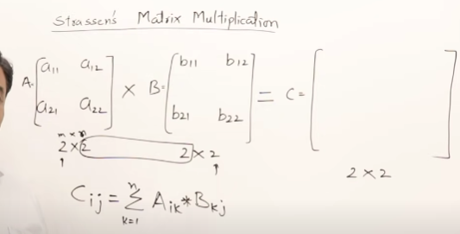

Above is the normal formula for matrix multiplication

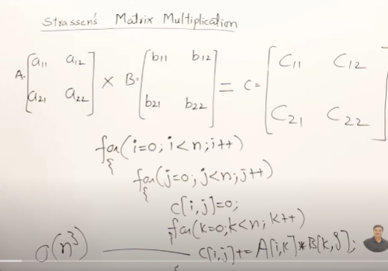

This approach will take time of O(n3).

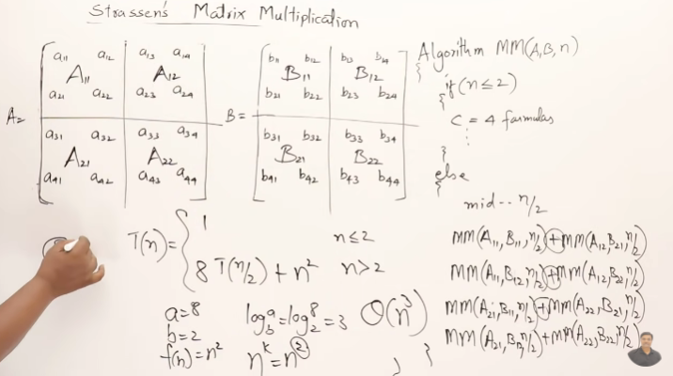

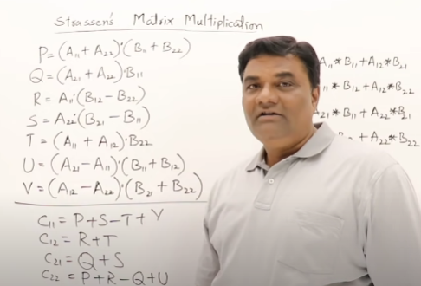

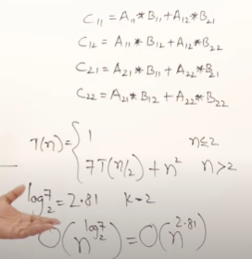

Using strassens formula also time complexity is O(n3). Also the drawback is taking more space here since recursive calls.

* Greedy Method:

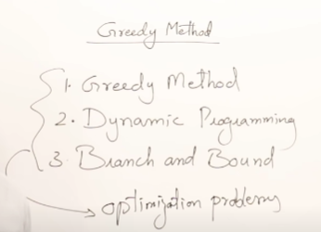

Above are the strategies used for solving optimization problems.

